Loan Application:

**Home Page:**

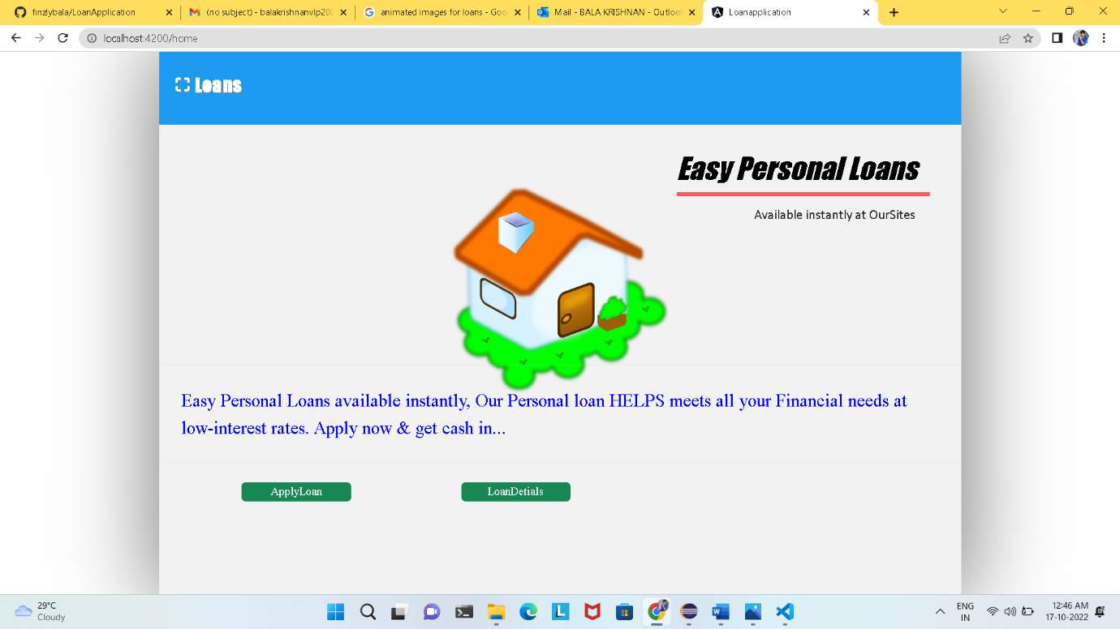

This is my Homepage and it has two buttons one is ApplyLoan and other one is LoanDetails. By clicking the ApplyLoan button it will redirect to the Loan Application page, and if you click on the LoanDetails button it will redirect to LoanDetails page.

**Loan creation page:**

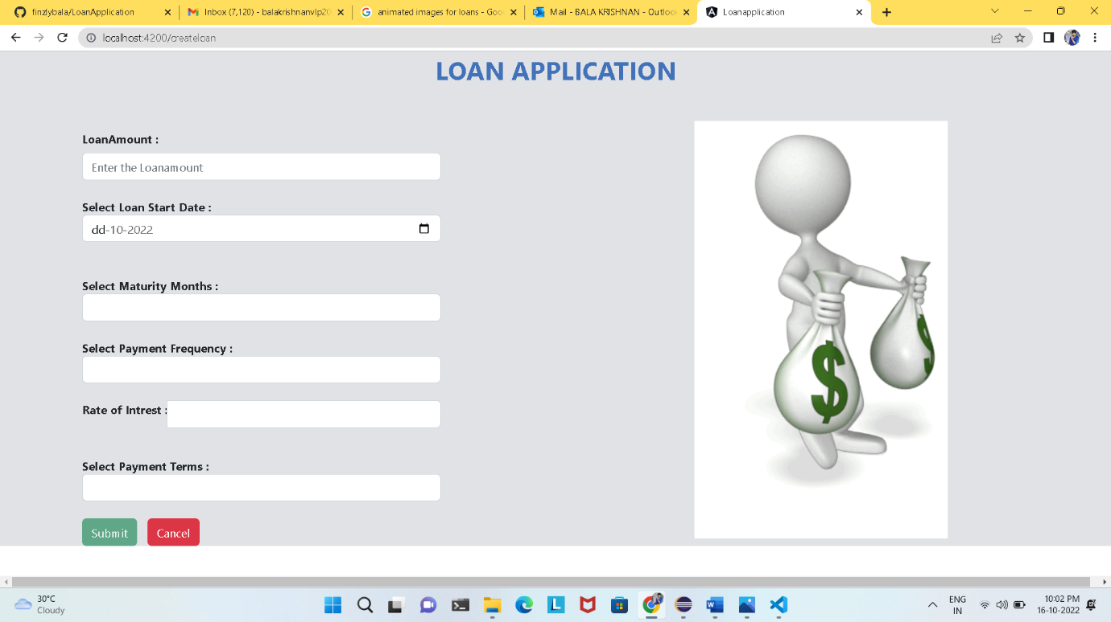

* In this page the customer can generate his lone.

**Validation:**

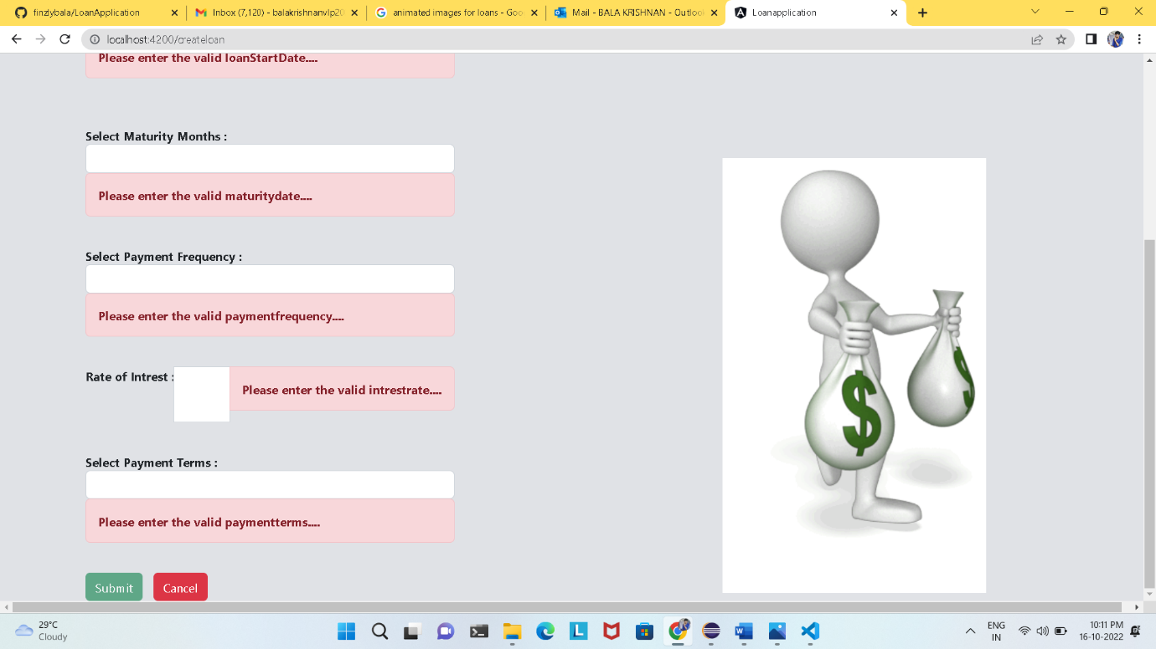

* If the customer did not enter any one of required values, the Submit button will not be enabled**.**

**Loan Amount Validation :**

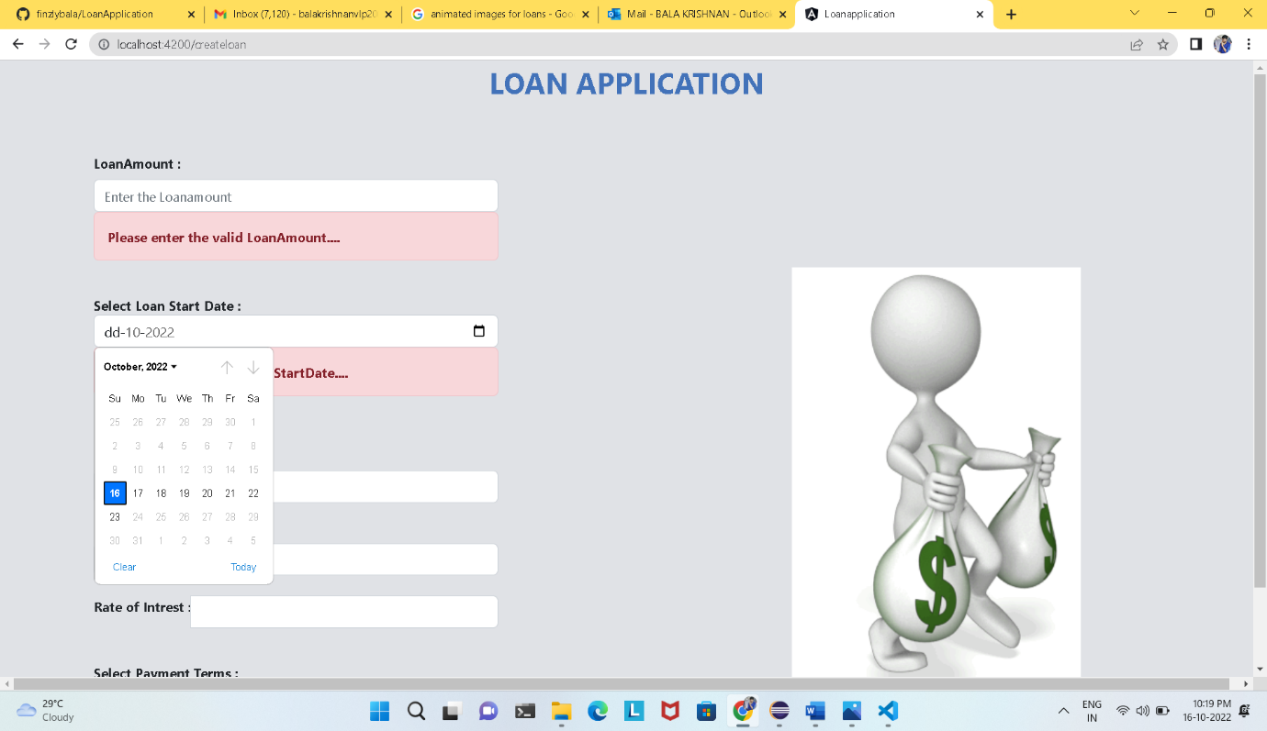

* The Loan amount is validated as minimum=1, and if it not entered any values and a danger message has been displayed. After entering a valid details the danger message will vanish.

**Loan Start Date Validation :**

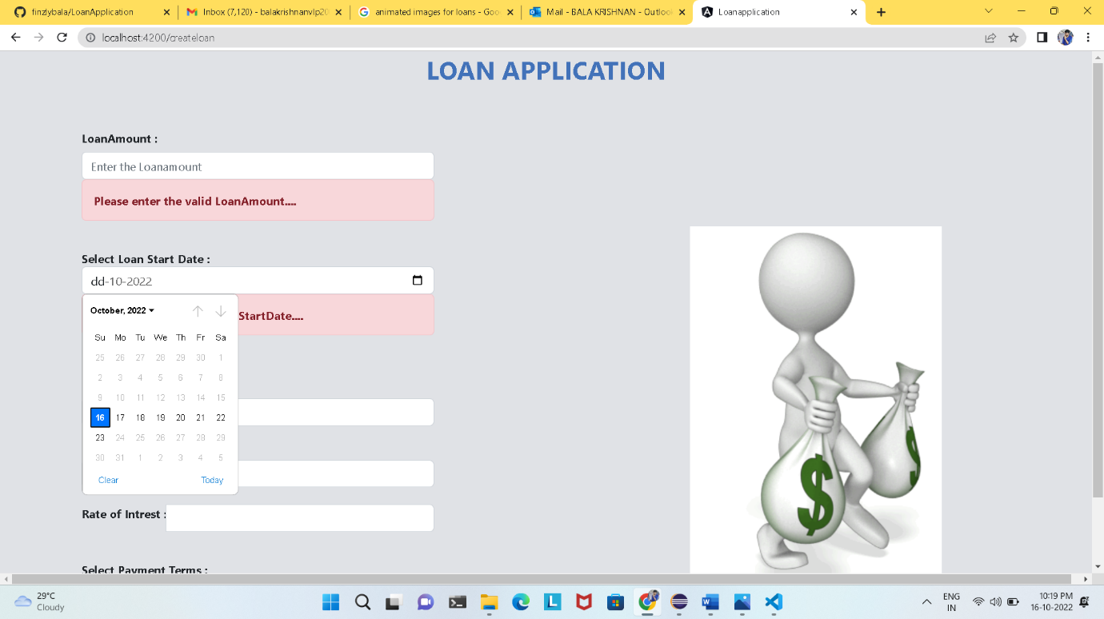

* The Loan Start Date is validated as the month and year has been set as default, and the Loan starting date was chosen by the customer as that the period was given as maximum as 7 days, from these days the customer can chose his loan starting date. The remaining past and future days was disabled.

**Maturity Month Validation:**

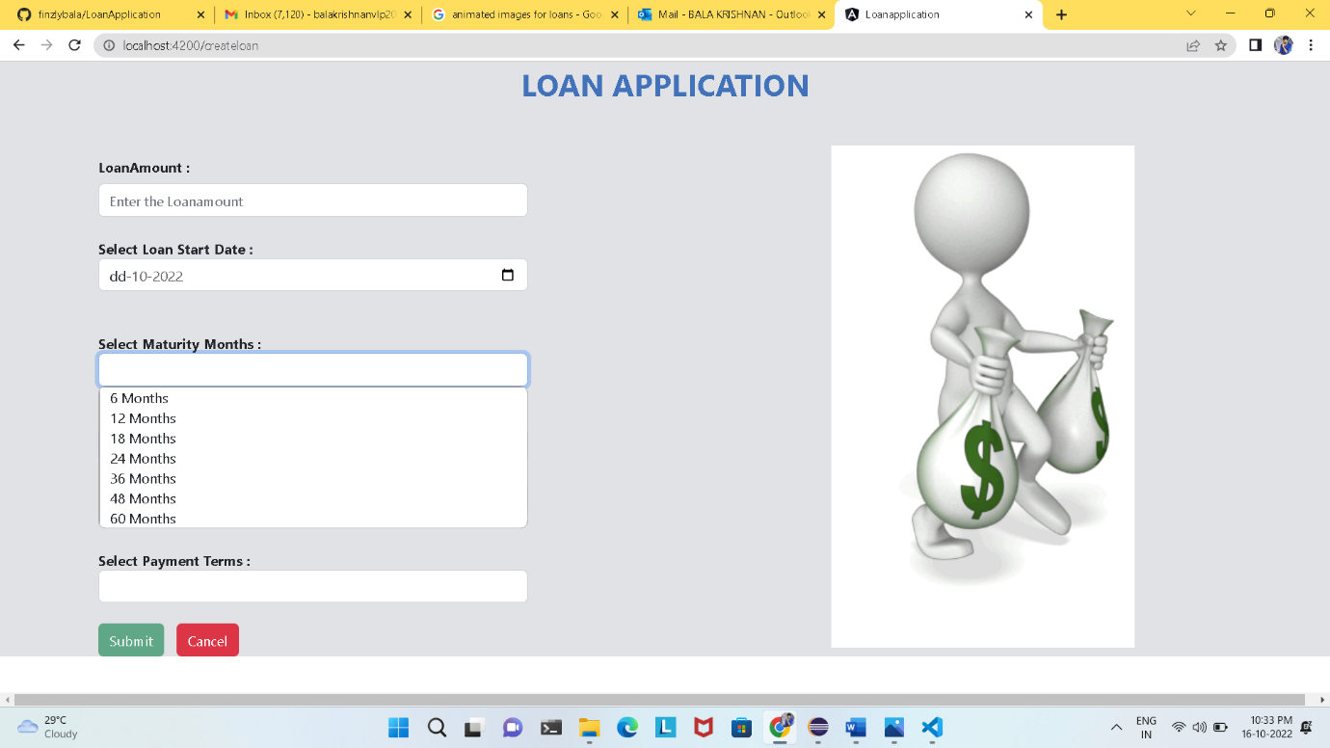

* The Maturity Month is validated as still 60 months (5years) only. Such that the customer should pay the entire lone amount in the period of maximum of 5years and the minimum he can pay his loan amount in 6 months. And if the customer has not selected any of the options a danger message was displayed.

**Payment Frequency Validation:**

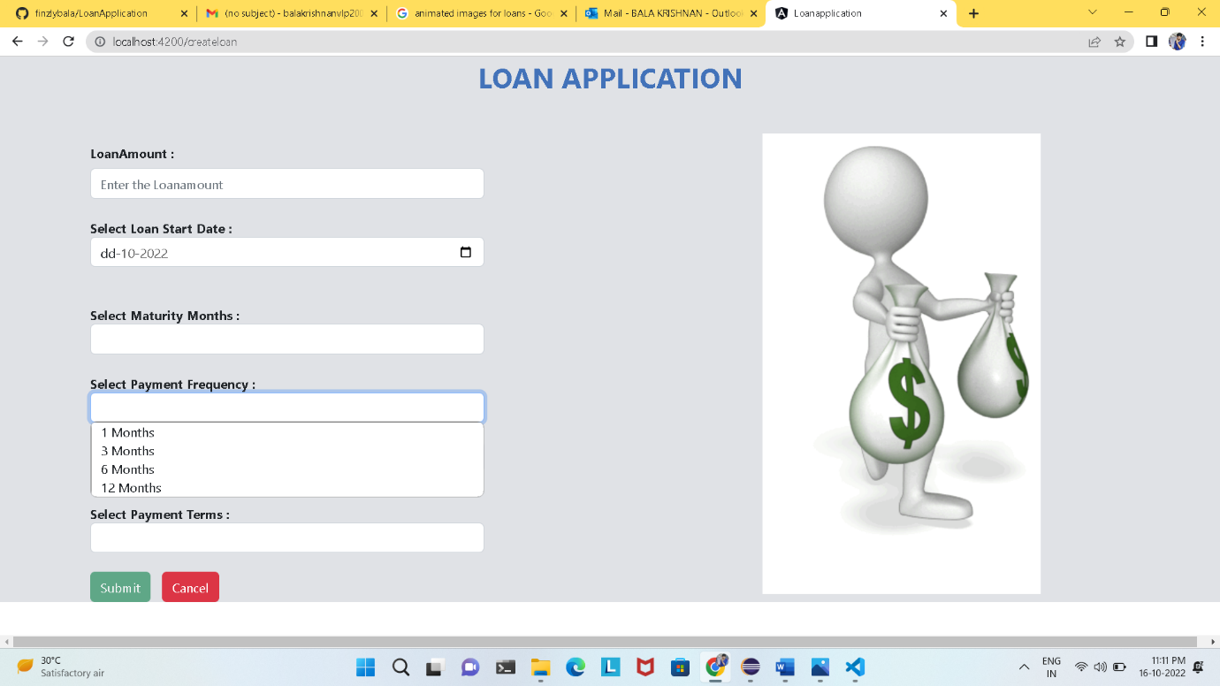

* The Payment Frequency was given as Monthly, Quarterly, Half-yearly, Yearly, Here the minimum frequency is 1month. And if the customer has not selected any of the options a danger message was displayed.

**Rate of Interest Validation:**

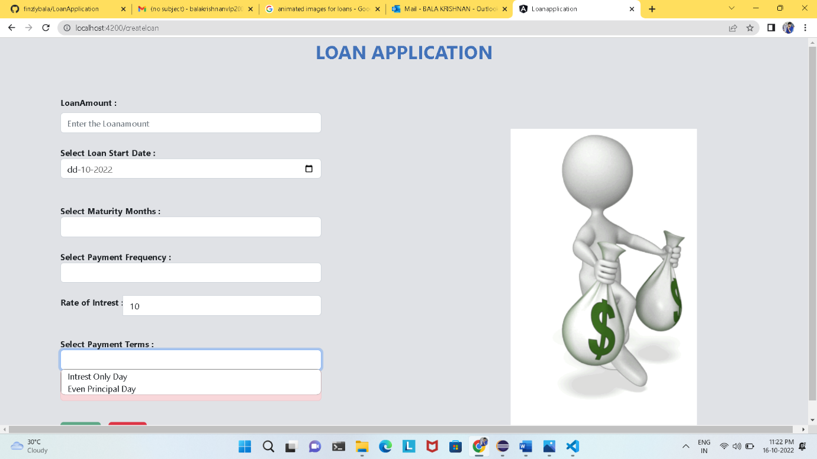

* The Rate of Interest was given as numbers, and this is validated as, it has been set as minimum value =1, and I have sated the maximum value =10. And if the customer has not selected any of the options a danger message was displayed.

**Payment Terms Validation:**

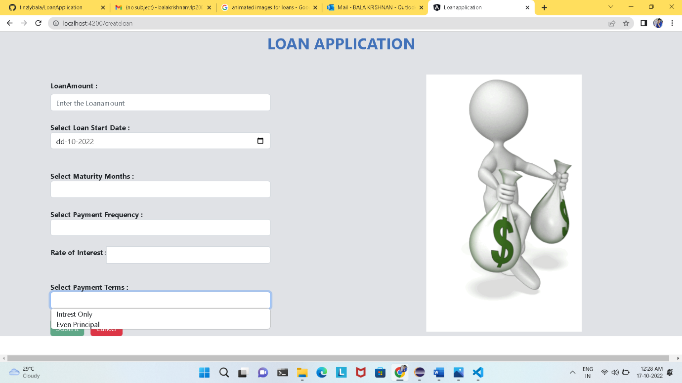

* The Payment Term is given as only two terms only INTEREST ONLY and the other one is EVEN PRINCIPAL. And if the customer has not selected any of the options a danger message was displayed

**Buttons:**

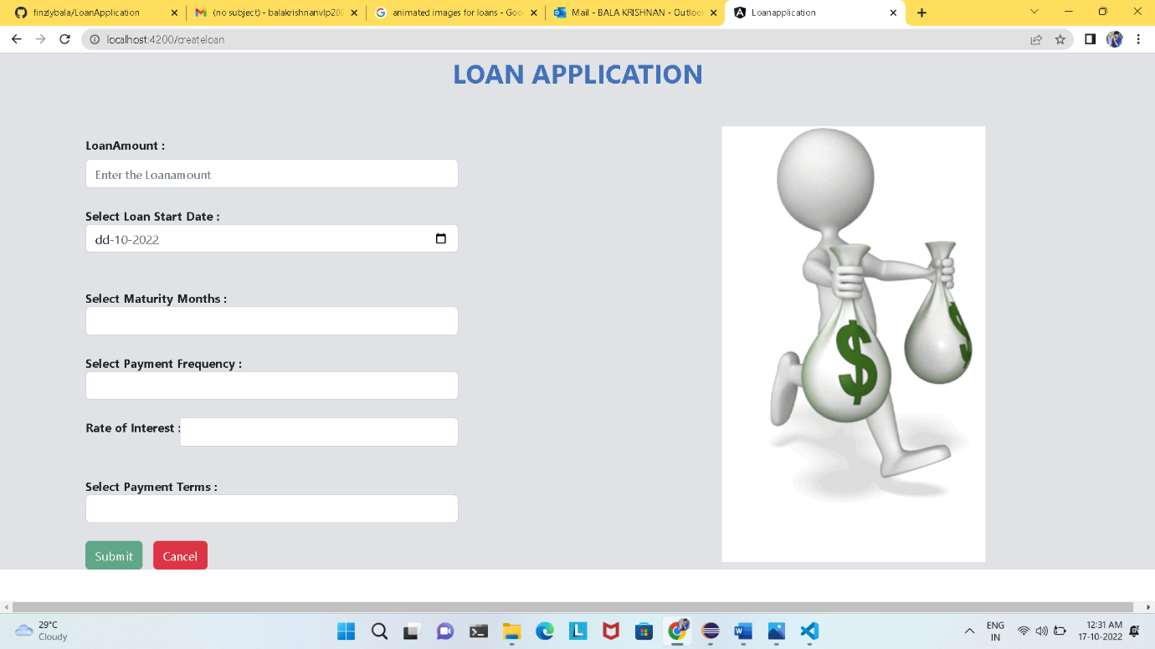 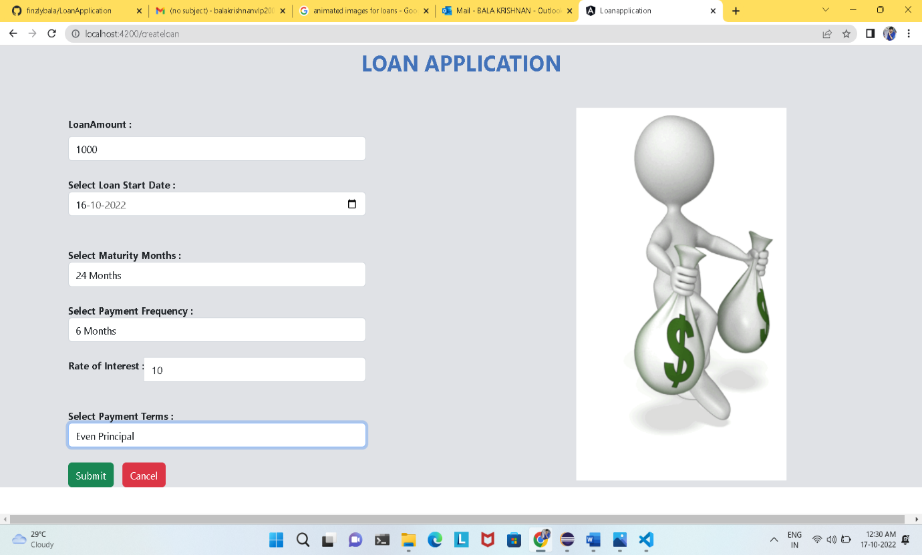

* The buttons are Submit and Cancel button, in which the Submit button in enabled when all the details are entered only. On the other hand the cancel button is visible at when the customer enters in the loan form itself.

**Alert Message:**

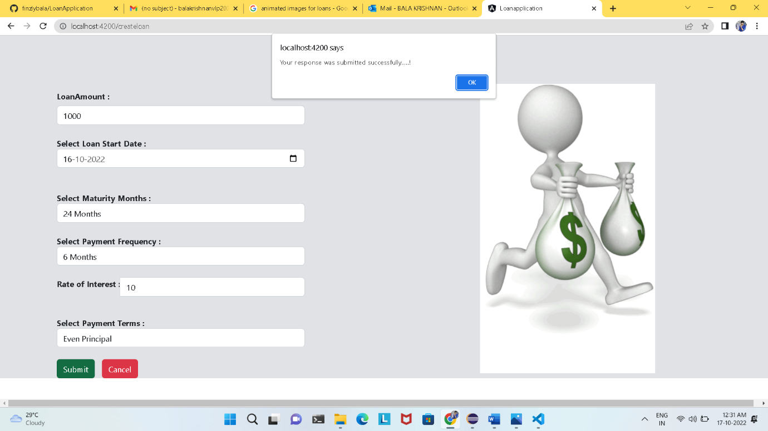

* When the Submit button is clicked an alert message is shown stated that “*Your response was submitted successfully….!*’and if the Button OK is clicked it will redirect to the Homepage.

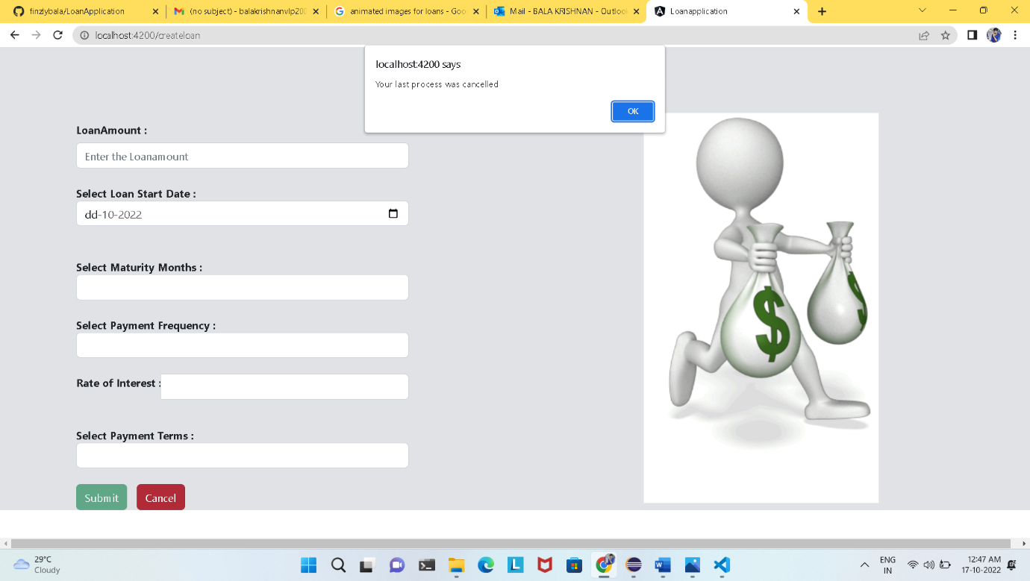

* When the Cancel button is clicked an alert message is shown states that “*Your last process was cancelled*” and if the Button Ok is clicked it will redirect to the Homepage.

**LoanDetails:**

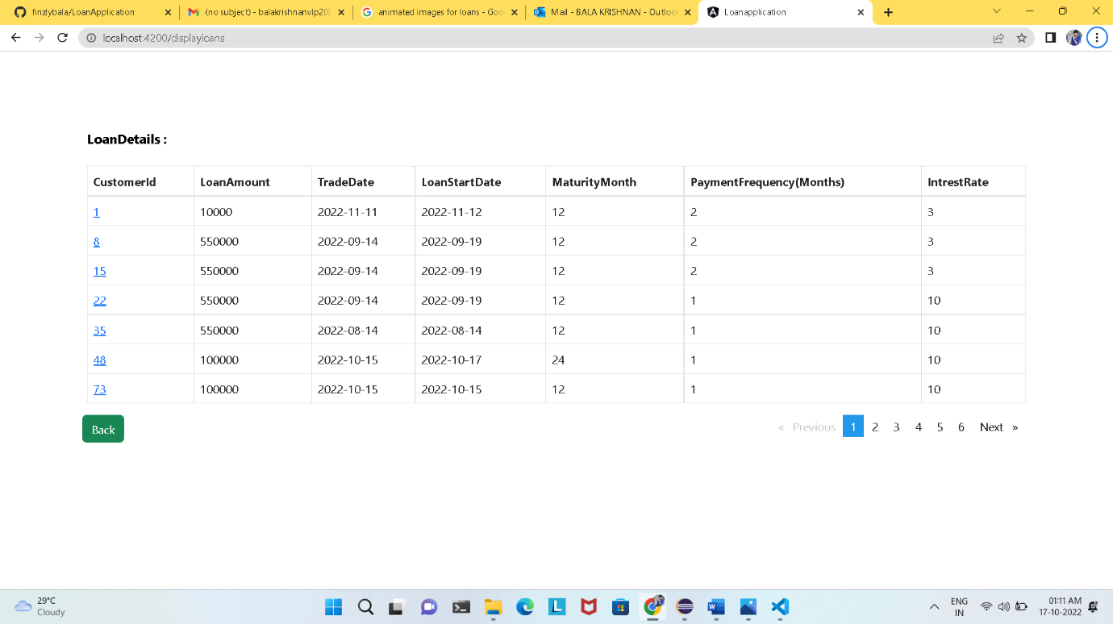

* This LoanDetails page, it just displays all the loan details that has been booked (History) with the customer id. Here there is an extra-feature is that by clicking on the customer id it will show the Payment Schedule of that particular customer id.
* By clicking the Back Button will redirect to the Homepage itself.

**Payment Schedule:**

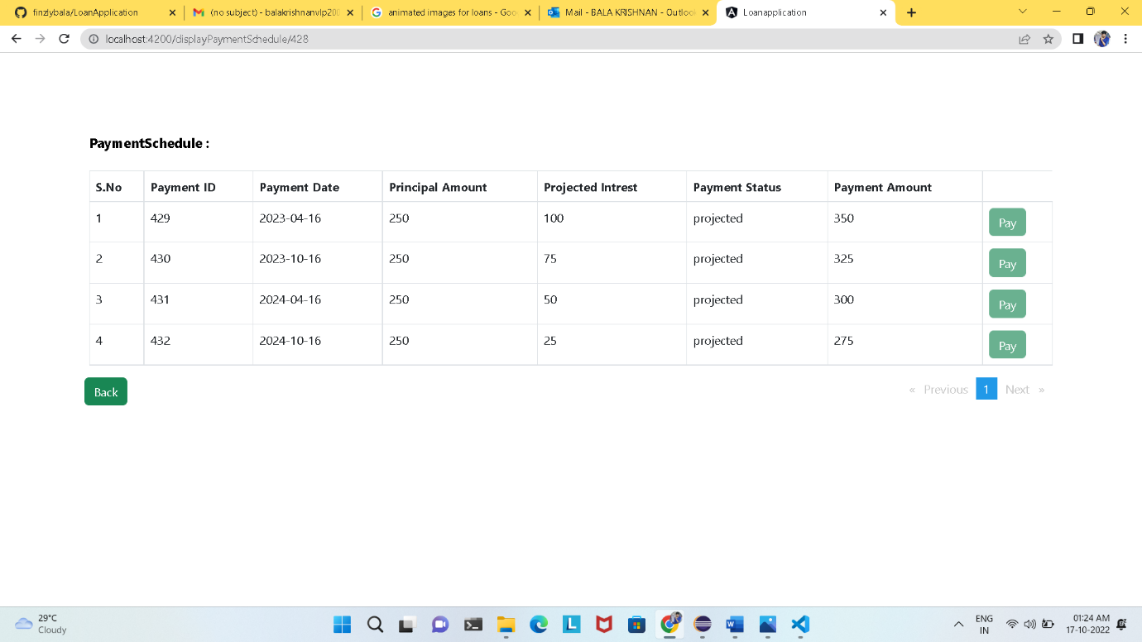

* There are two types of Payment Schedules are there as we discussed early, one is the Even Principal and another one is the Interest Only.
* The above mention figure displays the Even Principal Payment Schedule.
* By clicking the Back Button will redirect to the Loan Details page.

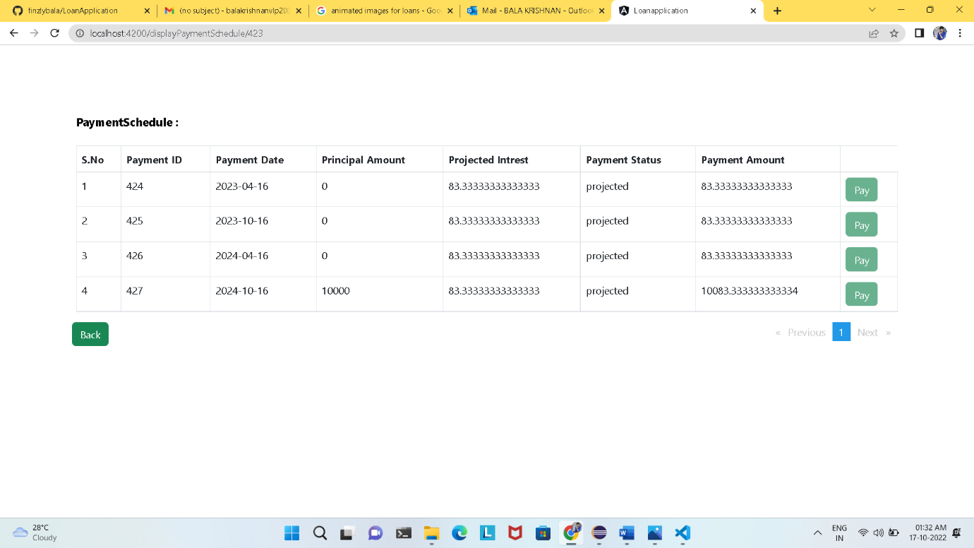

* The above mention is the Interest Only Payment Schedule.
* By clicking the Back Button will redirect to the Loan Details page.

There are three modes in Payment Status:

* Projected
* Awaiting Payment
* Paid

When ever the Payment status reaches the Payment schedule date at the time the Payment Status should be changed from Projected to Awaiting Payment and at this period the Pay button which is in the right side should be enabled for that particular Payment Id alone, than by clicking the Pay button the Payment Amount should be Paid, than the Awaiting Payment should be turned into Paid.

Let the upcoming figure displays this work flow:

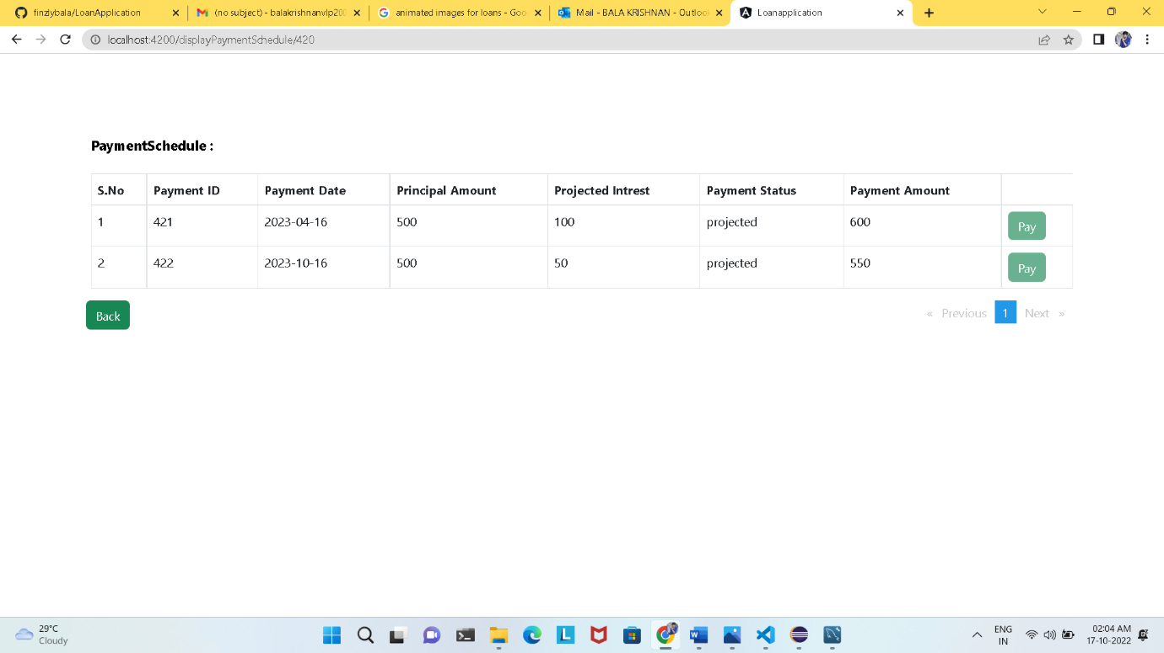

Let take the above Payment Schedule as example, now we can change the Payment Date for this particular Id.

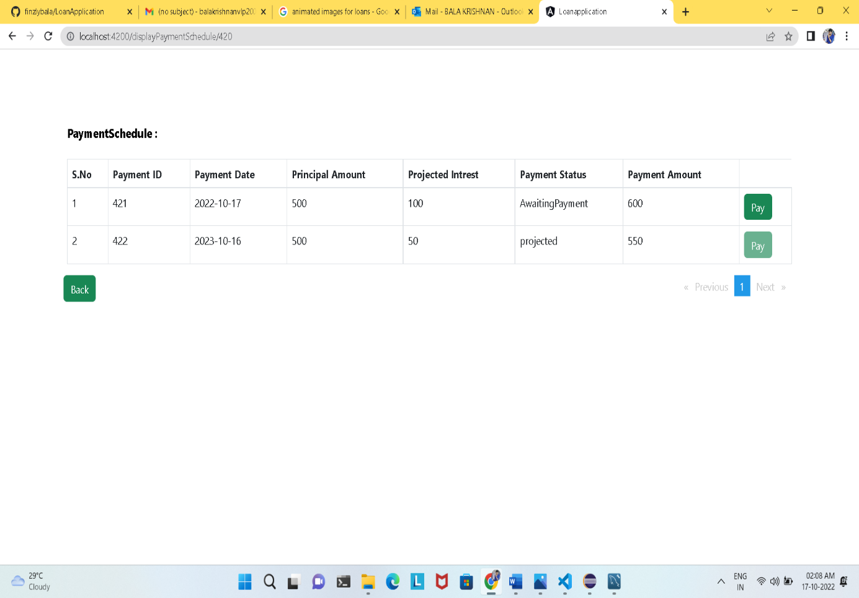

Now you can check it, in Payment Id 421 the Payment Date was changed and its current day, now in the Payment Status the Projected is turned into Awaiting Payment, and the Pay button is also visible.

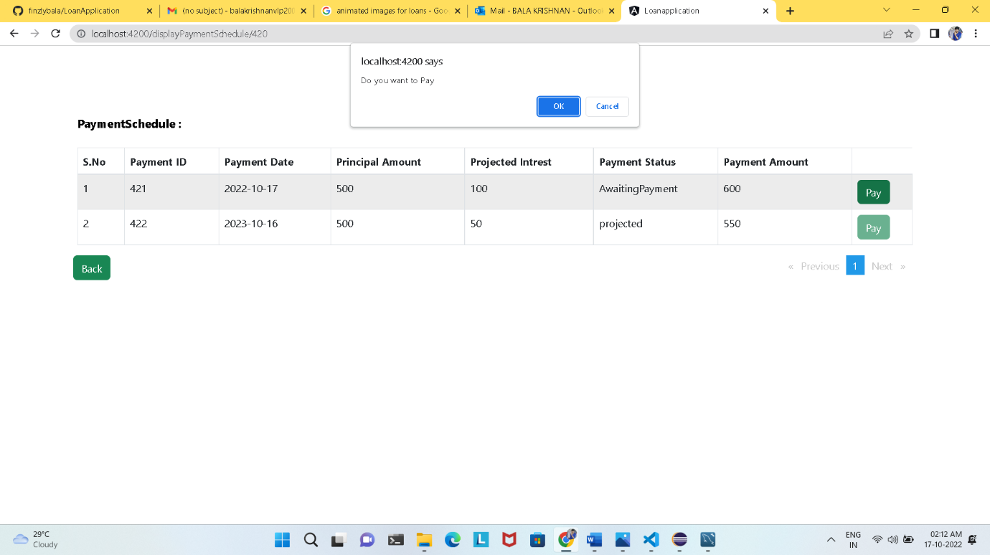

By clicking on the Pay button an alert message was displayed states ” *Do you want to Pay*”.

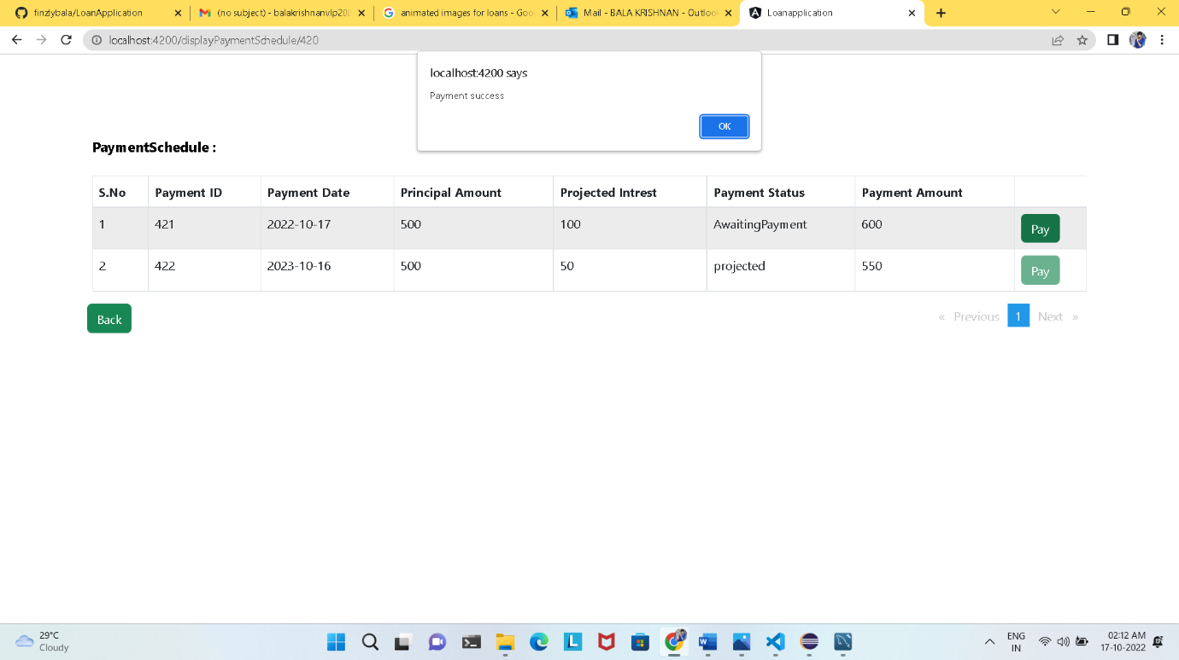

by clicking OK button next conformation alert message was displayed states “*Payment success* ”.

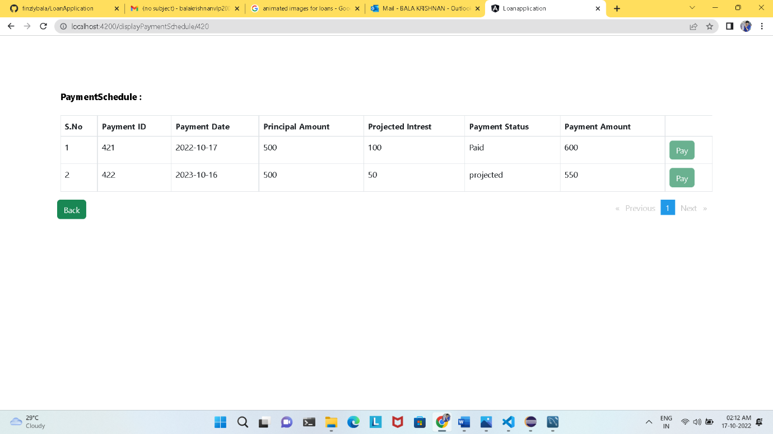

By clicking Ok, the Payment status turns into Paid, and again the paid button is disabled.

By clicking the Back button will redirect to the Loan Details.

**Page Not Found:**

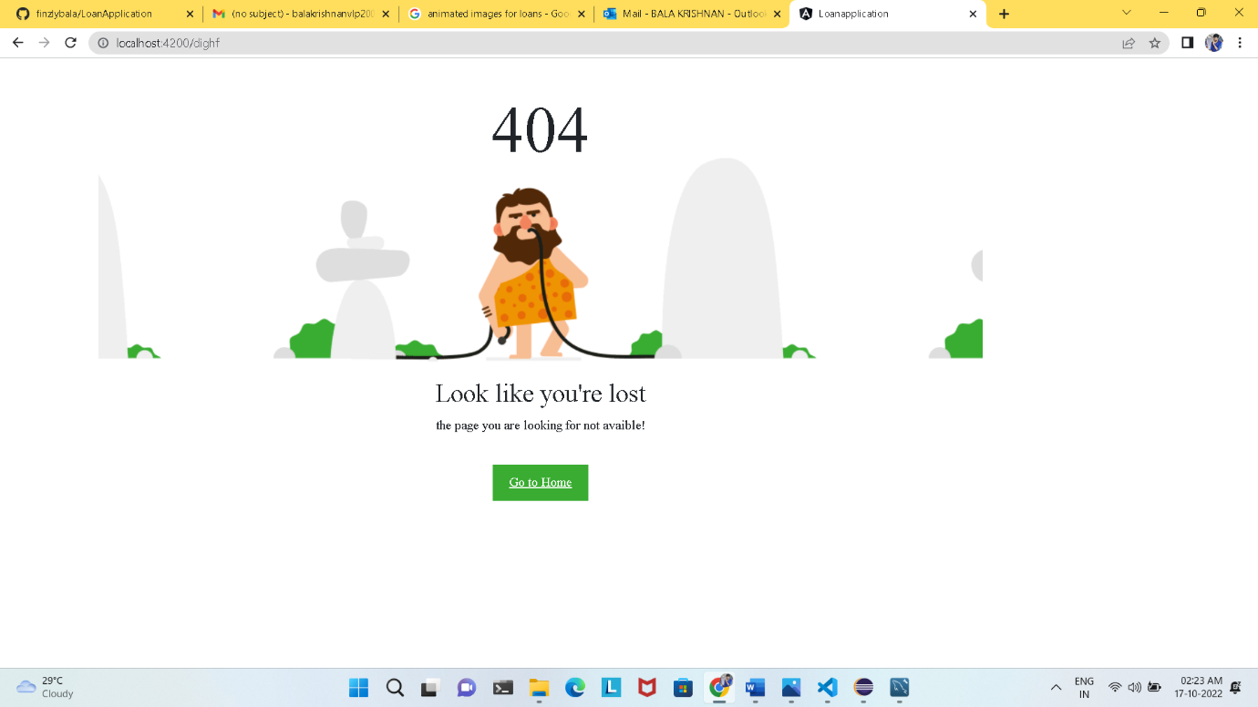

If any URL is given by mistake or any mistake in the URL it will throws the page to Page Not Font, and the above figure will be displayed.

By clicking the Go to Home button it will redirect to Homepage.